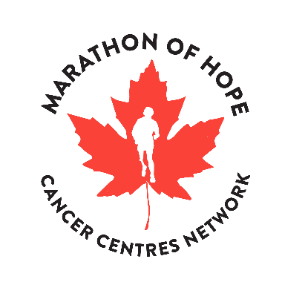
MARATHON OF HOPE CANCER CENTRES NETWORK
SCIENTIFIC PROGRESS REPORT – CONSORTIUM LEVEL

Scientific progress reports provide information to the Terry Fox Research Institute about the developments and achievements of research teams and feed into reports to Health Canada. Project Managers should use this template to report progress at the consortium level.

Consortium: BC2C / PR2C / PM2C / MOH-Q / ACC
Period Covered (select one and complete years):
☐ April 1, 20XX to September 30, 20XX
☐ October 1, 20XX to March 31, 20XX
Report Submitted By: Name, Email Address

Highlights
Using bullet points, provide context for material progress in the consortium- or individual centre-level capacities for precision medicine (such as new research infrastructure, new recruits and/or new clinical services that directly or indirectly have been aided by MOHCCN funding). Describe any knowledge products (e.g. Know-how, Intellectual Property, Guidelines). List any new Institutions joining the Consortium. Only include highlights that took place during this reporting period.

- Insert text here.

Consortium Activities
Complete and expand the table below to itemize progress in consortium activities funded by MOHCCN.

 | Activity | Date or Number | Ongoing (Y/N)
1 | Number of projects supported
2 | Consortium-level organized meetings, webinars, etc
3 | Consortium-level outreach events, patient engagements, etc
4 | Number of data transfer agreements/letters
5
6
Comments: Insert text here.

Future Work Plan
For six-month report: Comment on changes in the management or direction of projects during the period of this report, including processes used to reach decisions.
For fiscal year-end report: Itemize strategies, plans, arrangements, and funding for follow-on research, development and implementation of the project’s outcomes.

Insert text here.

Submission Date: 6-month: October 31, 20XX / Year-End: April 30, 20XX
Please replace “Template” in the file name with the short-form consortium name.
Submit To: mohreporting@tfri.ca
Appendix 1: Performance Indicators
Please only include indicators that are new during this reporting period.

- Significant New Collaborations
In the table below, identify new Network-affiliated researchers or healthcare decision makers who have joined the consortium during the reporting period. TFRI will survey these individuals in 2025 to ask whether the knowledge products produced by the Network have been useful in addressing gaps, needs and trends in precision oncology. Use the space for comments to provide additional context, if required.
Gender: Male, Female, Other, Prefer not to disclose
New Principal Investigators and Collaborators
 | Name | Affiliation | Gender (M/F/O/P) | Role | Email
1 | e.g. Smith, Joan | Credit Valley Hospital | F | CEO, Tech | jsmith@cvh.ca
1
2
3
Comments: Insert text here.

- Highly Qualified Personnel
In the table below, summarize the number of trainees funded through the consortium budget or through a cash match to study precision medicine approaches.
A table key is below.
Trainee Type: S = Scientific, C = Clinical, D = Data, and HI = Health Informatics. If other, please specify
Date: Insert month and year started and completed training
Gender: Male, Female, Other, Prefer not to disclose
Language of Training: French or English
HQP
 | Name | Institution | Trainee Type  (C/S/D/HI) | Start Date (mm/yyyy) | Date Completed (mm/yyyy) | Gender  (M/F/O/P) | Language of Training (F/E)
1 | e.g. Smith, Bob | UBC | HI | 09/2021 |  | M | F
1
2
Comments: Insert text here.

- Consortium Management
Using bullet points, report on important issues, policies or strategies discussed by the consortium’s governance committees. Report outcomes, where available.

- Insert text here.

